# Team Commit History

The following figures display the commit history of each member for the master branch, this is excluding merge commits.

**Figure 1: Cole’s Commit History**

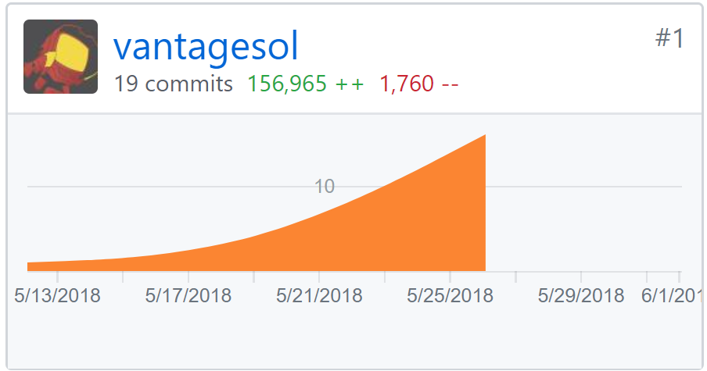

**Figure 2: Kris’s Commit History**

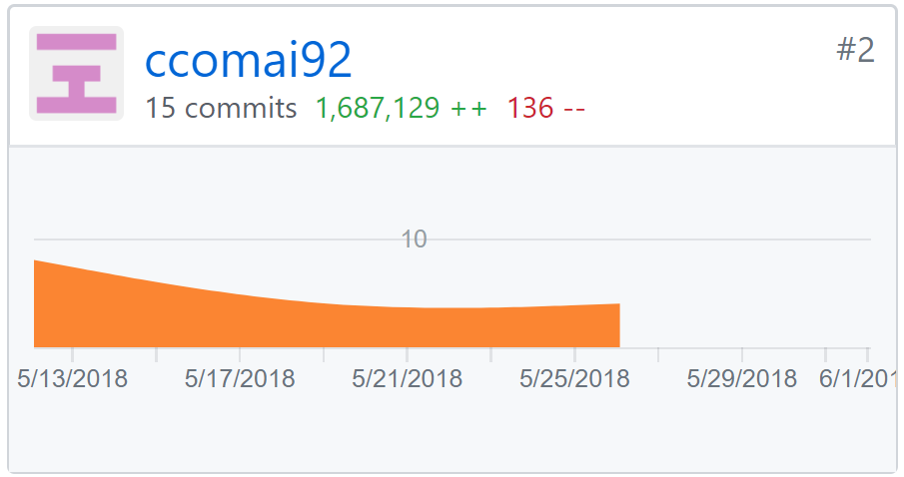

**Figure 3: Trece’s Commit History**

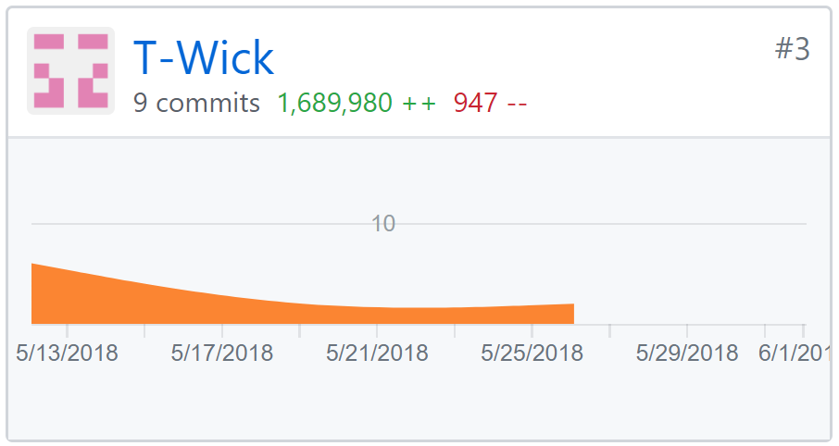

**Figure 4: Sam’s Commit History**

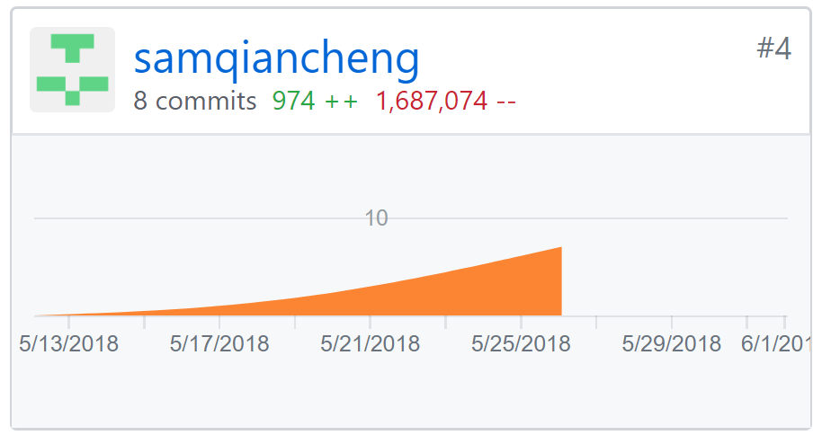

Originally we were only using the master branch but later decided to make multiple different branches at different points throughout this project, so the difference in commits to the master branch is a result of each one of us doing most of our work on different branches before merging them into the master branch. Additionally, we did a bunch of the coding as a group, we would meetup to discuss what needs to be done as far as coding goes, then we basically did paired programming and whoever’s laptop we did most of the work would usually be the one to commit.

# Additional Documentation

The following section shows illustrations of multiple collaborative sessions that our git history does not highlight, our team had these meetings in order to explain each others thinkings and make progress as we coded away at out project.

**Figure 5: Initial Layout of Classes**

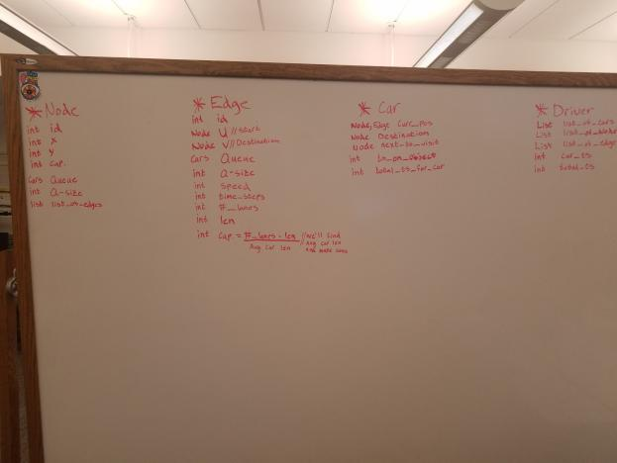

This photo was our original understanding of how we should layout the classes, their attributes, and their functionality.

**Figure 6: Creating the Congestion**

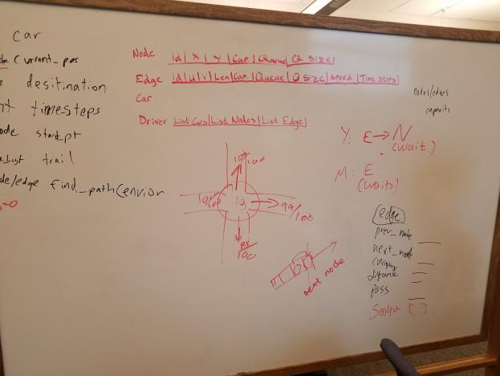

This shows how we decided to go about having our model create a congestion effect as cars begin to start traveling in the same areas too rapidly.

**Figure 7: Simple Pseudo Code**

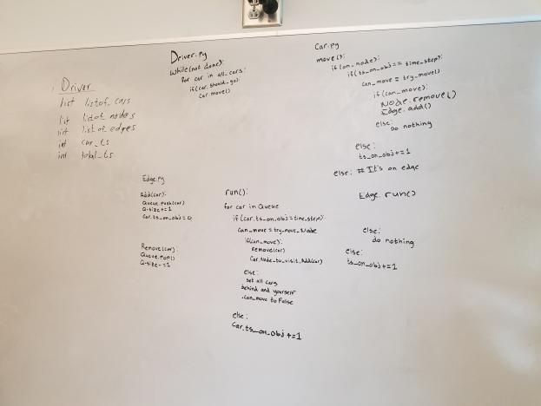

This was our first stab at trying to

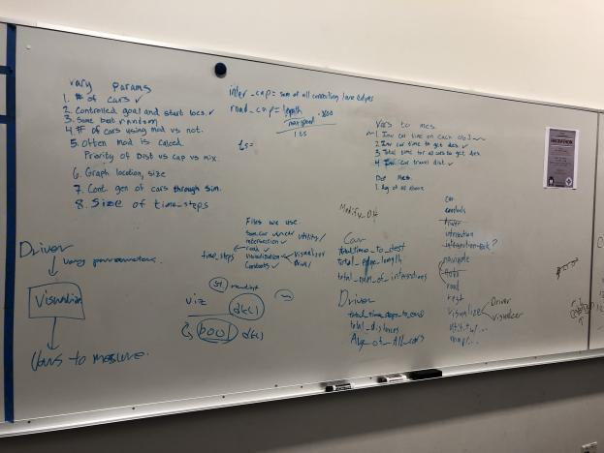

Figure 6

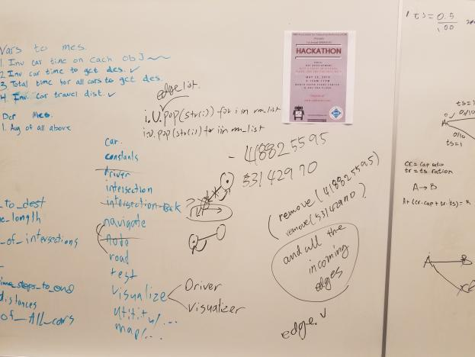

Figure 7:

